Ch. 2: Federalism - Take home FRQ
Please answer the following questions to the best of your ability.

“…Turning programs over to the states tends to result in the 50 capitals pursuing varying policy priorities and achieving disparate policy outcomes—not in a sleeker, more efficient government. Look at what happened with welfare, or the Temporary Assistance for Needy Families (TANF) program, which was turned into a fixed block grant to the states during the Clinton administration and has become a Republican exemplar of the efficiency argument ever since…But the welfare rolls shrank mostly because states kicked people off of the program, not because the program got more effective and efficient. An initiative that used to cover 68 of every 100 families in poverty now reaches just 23 of every 100 with cash benefits, the Center on Budget and Policy Priorities has found. Plus, given more flexibility and authority, states started using the money for initiatives other than cash benefits for poor mothers, such as early-childhood education and job training. That led to wide state-by-state differences in program outcomes. California covers 65 out of every 100 families in poverty with cash benefits under TANF, for instance, while Louisiana covers just four.”

- Are States Really More Efficient Than the Federal Government? By Annie Lowry, The Atlantic, 2017

- Describe the concept of federalism being described in the scenario above.
- In the context of the scenario, explain how the concept described in part A can have an affect on the quality of national programs.
- Explain how the political party make up of state legislatures can affect policy implementation.
A.____________________________________________________________________________________________________________________________________________________________________________________________________________________________________________________________________________________________________________________________________________________________________________________________________________________________________________________________________________________________________________________________________________________________________________________________________________________________________________________________________________________________________________________________________________________

B.________________________________________________________________________________________________________________________________________________________________________________________________________________________________________________________________________________________________________________________________________________________________________________________________________________________________________________________________________________________________________________________________________________________________________________________________________________________________________________________________________________________________________________________________________________________________________________________________________________________________________________________________________________________________________________________________________________________________________________________________________________________________________________________________________________________________________________________________________________________________________________________________________________________________________________________

C.__________________________________________________________________________________________________________________________________________________________________________________________________________________________________________________________________________________________________________________________________________________________________________________________________________________________________________________________________________________________________ ___________________________________________________________________________________________________________________________________________________________________________________________________________________________________________________________________________________________________________________________________________________________________________

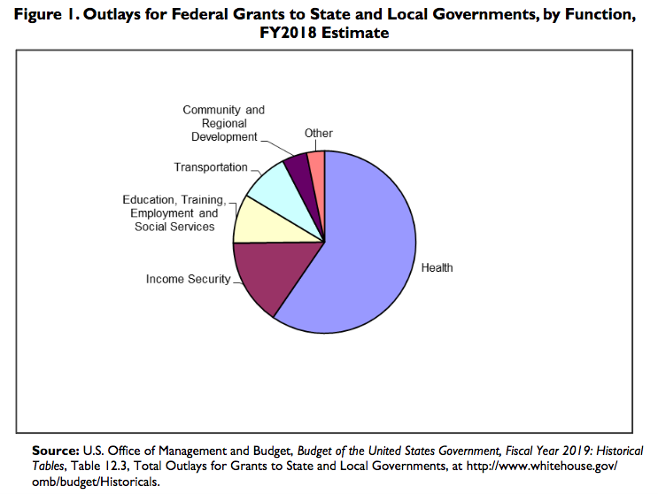
Use the information in the chart to answer the questions.
- Identify the most common federal grant given to state and local governments for fiscal year (FY) 2018.
- Describe a similarity or difference in federal grants to state and local governments in FY2018. Draw a conclusion about that similarity or difference.
- Explain how grants can affect the relationship between the national government and state and local governments.
A.____________________________________________________________________________________________________________________________________________________________________________________________________________________________________________________________________________________________________________________________________________________________________________________________________________________________________________________________________________________________________________________________________________________________________________________________________________________________________________________________________________________________________________________________________________________

B.________________________________________________________________________________________________________________________________________________________________________________________________________________________________________________________________________________________________________________________________________________________________________________________________________________________________________________________________________________________________________________________________________________________________________________________________________________________________________________________________________________________________________________________________________________________________________________________________________________________________________________________________________________________________________________________________________________________________________________________________________________________________________________________________________________________________________________________________________________________________________________________________________________________________________________________

C.__________________________________________________________________________________________________________________________________________________________________________________________________________________________________________________________________________________________________________________________________________________________________________________________________________________________________________________________________________________________________ ___________________________________________________________________________________________________________________________________________________________________________________________________________________________________________________________________________________________________________________________________________________________________________

