POTUS AND COTUS - Take home FRQ
Please answer the following questions to the best of your ability
1. In 1949, a select Senate subcommittee discovered corruption within the administration of President Harry S. Truman. As a result, several agencies were reorganized and a special White House commission was appointed to investigate evidence of corruption in all areas of government.
In the late 1960s, televised hearings of the Senate Foreign Relations Committee on the so-called Pentagon Papers solidified public opposition to continued U.S. participation in the Vietnam War, hastening the end of the conflict.
Less than a year after details of the 1973 Watergate scandal were exposed, the House Judiciary Committee's impeachment proceedings against President Richard Nixon resulted in his resignation from office

During 1996 and 1997, the Senate Finance Committee investigated and confirmed whistleblower reports from Internal Revenue Service (IRS) tax collection agents that they had been pressured by their supervisors to harass citizens who claimed they had been wrongly accused of owing unpaid taxes.

After reading the scenarios, respond to A, B and C below:
- Describe the main function of Congress addressed in the scenarios above.
- In the context of the scenarios, explain how the function referenced in part A could be affected by Congressional leadership
- In the context of the scenarios, explain how checks and balances are demonstrated.
A.____________________________________________________________________________________________________________________________________________________________________________________________________________________________________________________________________________________________________________________________________________________________________________________________________________________________________________________________________________________________________________________________________________________________________________________________________________________________________________________________________________________________________________________________________________________

B.________________________________________________________________________________________________________________________________________________________________________________________________________________________________________________________________________________________________________________________________________________________________________________________________________________________________________________________________________________________________________________________________________________________________________________________________________________________________________________________________________________________________________________________________________________________________________________________________________________________________________________________________________________________________________________________________________________________________________________________________________________________________________________________________________________________________________________________________________________________________________________________________________________________________________________________

C.__________________________________________________________________________________________________________________________________________________________________________________________________________________________________________________________________________________________________________________________________________________________________________________________________________________________________________________________________________________________________ ___________________________________________________________________________________________________________________________________________________________________________________________________________________________________________________________________________________________________________________________________________________________________________

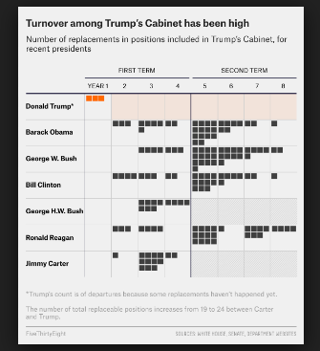
*As of late 2017

2. After reading the excerpt, respond to A, B and C below:
- Identify the Constitutional provisions that are necessary for cabinet members to attain office.
- Describe a similarity or difference in cabinet member replacements, as illustrated in the chart above, and draw a conclusion about the similarity or difference.
- Explain how the number of cabinet level officials removed by the president and replaced by other officials can have an affect on policy outcomes.
A.____________________________________________________________________________________________________________________________________________________________________________________________________________________________________________________________________________________________________________________________________________________________________________________________________________________________________________________________________________________________________________________________________________________________________________________________________________________________________________________________________________________________________________________________________________________

B.________________________________________________________________________________________________________________________________________________________________________________________________________________________________________________________________________________________________________________________________________________________________________________________________________________________________________________________________________________________________________________________________________________________________________________________________________________________________________________________________________________________________________________________________________________________________________________________________________________________________________________________________________________________________________________________________________________________________________________________________________________________________________________________________________________________________________________________________________________________________________________________________________________________________________________________

C.__________________________________________________________________________________________________________________________________________________________________________________________________________________________________________________________________________________________________________________________________________________________________________________________________________________________________________________________________________________________________ ___________________________________________________________________________________________________________________________________________________________________________________________________________________________________________________________________________________________________________________________________________________________________________

3. 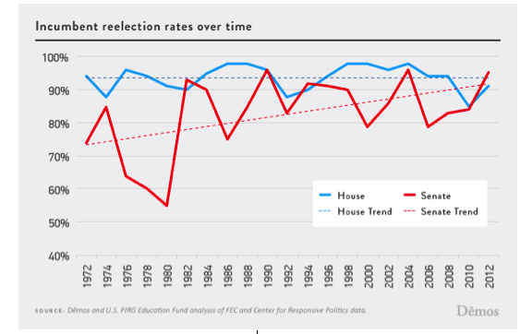
After reading the excerpt, respond to A, B and C below:
- Identify a trend in the chart above.
- Describe a similarity or difference in incumbency reelection rates over time, as illustrated in the chart above, and draw a conclusion about the similarity or difference.
c. Explain why incumbents have an advantage over their challengers during election cycles for seats in the House and Senate

A.____________________________________________________________________________________________________________________________________________________________________________________________________________________________________________________________________________________________________________________________________________________________________________________________________________________________________________________________________________________________________________________________________________________________________________________________________________________________________________________________________________________________________________________________________________________

B.________________________________________________________________________________________________________________________________________________________________________________________________________________________________________________________________________________________________________________________________________________________________________________________________________________________________________________________________________________________________________________________________________________________________________________________________________________________________________________________________________________________________________________________________________________________________________________________________________________________________________________________________________________________________________________________________________________________________________________________________________________________________________________________________________________________________________________________________________________________________________________________________________________________________________________________

C.__________________________________________________________________________________________________________________________________________________________________________________________________________________________________________________________________________________________________________________________________________________________________________________________________________________________________________________________________________________________________ ___________________________________________________________________________________________________________________________________________________________________________________________________________________________________________________________________________________________________________________________________________________________________________

4. “Over the nation's long history, with only short interruptions, power has flowed increasingly to the Executive Branch. The reasons for this are numerous, but include the successful exercise of power by ambitious presidents from Lincoln to the two Roosevelt’s, the growth of the administrative state in the 20th century, and the realization that Congress is ill-suited compared to the President to make timely responses to national security threats”

After reading the excerpt, respond to A, B and C below:
- Describe a type/example of power that has allowed the presidency to increase its role over time
- In the context of the excerpt, explain how the power referenced in part A could be affected by Congressional power
- In the context of the excerpt, explain why the powers expressed in Article II by the framers were limited compared to those enumerated in Article I.
A.____________________________________________________________________________________________________________________________________________________________________________________________________________________________________________________________________________________________________________________________________________________________________________________________________________________________________________________________________________________________________________________________________________________________________________________________________________________________________________________________________________________________________________________________________________________

B.______________________________________________________________________________________________________________________________________________________________________________________________________________________________________________________________________________________________________________________________________________________________________________________________________________________________________________________________________________________________________________________________________________________________________________________________________________________________________________________________________________________________________________________________________________________________________________________________________________________________________________________________________________________________________________________________________________________________________________________________________
C._________________________________________________________________________________________________________________________________________________________________________________________________________________________________________________________________________________________________________________________________________________________________________
_________________________________________________________________________________________________________________________
___________________________________________________________________________________________________________________________________________________________________________________________________________________________________________________________________________________________________________________________________________________________________________

